### **Paper 11: Effects of age and gender on success and death of mountaineers on Mount Everest**

**Dataset** : Himalayan Database

Other datasets: None

**Comments:**1.This paper was published in 2007 which is more than 15 years ago. With changes in the identity of people who now have access to information and resources to attempt such expeditions within the past decade, has that made a difference in the analysis?  
Time period of analysis : **1990-2005.**  
2. This paper is aligned to the Causal Inference topics covered in our course as well as prediction uncertainty.

3. Gender ratio has been shifting since the first ascent in 1953. (YOY comparison).

4. Age ratio has also been shifting. In the early decades, 18.7% were >=40yrs. In 2000-2005, 45.6% >=40yrs and 3.6%>60yrs.

5. Prior experience increased with age (up until 30 years of age).

6. Older climbers may be less likely to summit because they are physically less capable

(Moore 1975; Burtscher 2004; Tsianos et al. 2006) or they climb in a more conservative manner.

7. Will considering log odds make a difference in the analysis?

8. Note : weather not discussed

| **Objective** | **Time Range** | **Data filters** | **Missing factor** | **Factors** | **Analysis** | **Results** |
| --- | --- | --- | --- | --- | --- | --- |
| 1.Impact of age on success on  A. Chances (odds) of summiting (success)  B. Chances (odds) of survival/death upon **descent only**  (to equalize age)= Descent death rate | 1990 -2005 | 1. Mount Everest Expedition  2. First Attempt  3.Only members (no high altitude assistants)  4.No Chinese excursions since these do not distinguish between members and helpers.  5.Season: Spring (when most attempts are made | **Oxygen usage.**  We might want to consider if this is more prevalent now that there are more commercial expeditions that do not want to take risks. | Proxy for skill (0, 1): Whether a climber had previously attempted a Nepalese peak. | 1. GAM Joint-Point Regression.  2. Rates (of summiting) were non-linearly related to age and appeared to show a breakpoint, anm age at which rates shifted abruptly.  3. To compare the death rates of climbers who reached equivalent altitudes, we analyzed the death rates only of climbers descending from Everest’s summit (NZ677; figure 1b).  4. We fit a **GAM joint-point regression** model (less than  60 years versus 60 years and above). | 1. A comparison of overall death rates underestimates risks facing older climbers simply because very few older climbers reach extreme altitudes where the risk is greater. (Are they more conservative now as well?)  2. Overall death rate changed little until the age of ~60 years but then increased suggestively thereafter.  3. Death rate was independent of gender  ( pZ0.91), as men and women had similar death rates  (1.62 and 1.63%, respectively)  4.. Death rate was also  independent of experience and route.  5. Climbers with prior experience on a Nepalese peak had elevated rates of summiting (38.7% versus  25.7%) though not a lower death rate |
| Consider if this has made a difference in survival rates. | Age: bins of 10 years |
| Gender (Men/Women) |
| Route |
|

**Statistical visualization**

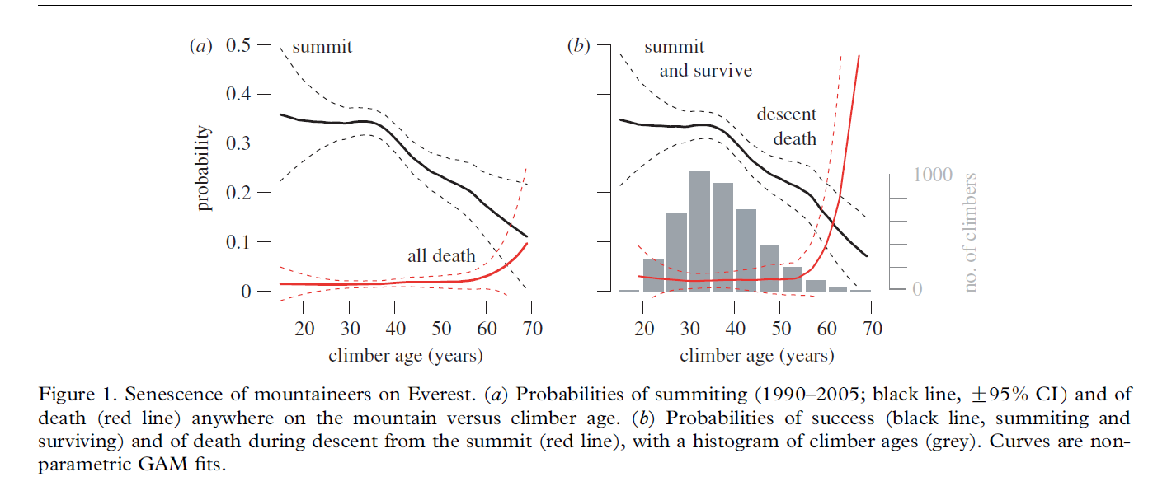

**Quotes: None**

**Paper Credits**

Huey, R. B., Salisbury, R., Wang, J.-L., & Mao, M. (2007). Effects of age and gender on  
success and death of mountaineers on Mount Everest. *Biology Letters*, *3*(5), 498–500.<https://doi.org/10.1098/rsbl.2007.0317>

### **Paper 12: SUCCESS AND DEATH ON MOUNT EVEREST**

**Dataset** : Himalayan Database

Other datasets: None

**Comments:**

- Stakeholder (Expeditioner) : Use data to guide your decision on when to climb and which route to take with a view to maximize chances of summiting and reduce chances of death **Questions to be answered by data (Risk Analysis):**

**1.** Which route has the highest success rate?

2. Which route has the highest death rate?

3. Do success or death rates differ between spring and fall?

4. Have success rates improved (or have death rates declined) in recent years?

[Note : weather not discussed

NOTE: the below discussion emphasizes that even elite climbers have limited routes and will appreciate the information from prediction on non-popular routes and seasons to make their journey in for the various peaks ]

“Even many of the elite climbers are seemingly becoming more conservative. Consider

the 50 climbers who have summited 10 or more of the 8,000m peaks (including Everest). Of

those who first summited Everest between 1978 and 1989, 1 in 3 climbed a non-standard

route; but of those who summited thereafter, significantly fewer (1 in 15) climbed a non-standard

route. Perhaps the expanding quest for all fourteen 8000ers is encouraging even elite

climbers to just “bag” Everest and get on with the remaining peaks” Page 8

**Route choice determination**

1.The earliest expeditions (British, 1920s) approached Everest from the north (Tibet).None is believed successful.  
2. Southern route opened when Nepal permitted foreign climbers. Tibet closing due to invasion (Political aspect)

3. Southern route advantages : “For one thing the sun would be on the climber most of the day to mollify somewhat the extreme cold on the shadowed northern slopes. The strata of the sedimentary rocks, which slope downward like shingles on a roof on the unusual northern route, would offer better hold on the south”. Success in 1953. Tibet opened 1980.

4. Season advantage seen in data:The dramatic shift to the spring may reflect an

awareness that a calm-weather period is relatively predictable in May and perhaps a growing

awareness that the success rate of climbers in spring is relatively high.

**Death Rates on Everest to assess risk**

1. A total of 91 climbers and 38 H-A porters died on Everest between 1980

and 2002.

| **Objective** | **Time Range** | **Data filters** | **Missing factor** | **Data segmentation** | **Factors** | **Analysis** | **Results** |
| --- | --- | --- | --- | --- | --- | --- | --- |
| Routes and seasons as predictors of success | 1980  -2002  (Nepal and Tibet were open) | 1.Season : Spring  *analysis offered **sometimes** for other seasons or all seasons combined  2. Members Only (not helpers) *Foreign guides are considered as climbers, as  per permit policies.  3. Chinese expeditions filtered out as there is no distinction in members and helpers.  4. Cimber went above base camp  5 Mount Everest expeditions only |  | **Groups**  1) Those using only the classical South Col-  Southeast Ridge (“South Col”) in Nepal   2) those using only the  North Col-North Face-Northeast Ridge (“North Col”) in Tibet  3) all  “other”  **Individual/Expedition** *An expedition is considered  successful if at least one climber reached the summit. | 1 Seasons | 1.To help illustrate historical trends,  we added smoothed curves (“lowess smoothers,” which are similar to running averages) to  the graphs. | Favored Season  1 Traditionally Spring but switched to autumn in 80s and back to spring in 90s but winter is also chosen. Not summer.  2 Is a year that is good on the North Col also good on the South Col? Surprisingly, the answer  is no! The success rates of climbers in spring from the north vs. from the south are completely  Uncorrelated.  3 Has a mountaineer’s chance of summiting increased over time? On the South Col, success  rates in spring have increased sporadically (though significantly) since 1980; but note that  the best year ever was early: 1985 (Fig. 3a). On the North Col, success rates were generally low  prior to 1995 but increased dramatically thereafter.  **4 These recent shifts seemingly reflect an increasing conservatism on**  **Everest, with the vast majority of climbers concentrating on the season and routes that maximize**  **their chance of success. Indeed, 95% of all “Seven Summiters” to date climbed a main**  **route on Everest.**  5 Success rates on the main routes have increased the past quarter century (Fig. 3), yet  death rates have remained stable. In some ways these patterns are surprising, given the widespread  belief that contemporary Everest climbers are on average less experienced and skilled  than their predecessors. If that belief is accurate, then the decline in average skill and experience  has been more than balanced by improved equipment and logistics, better weather forecasting,  greater cumulative knowledge of the routes, and enhanced skill and experience of HA  porters and leaders. |
|  | 2 Routes (see groups) |
| |  | | --- | |
|
|

**Statistical visualization**

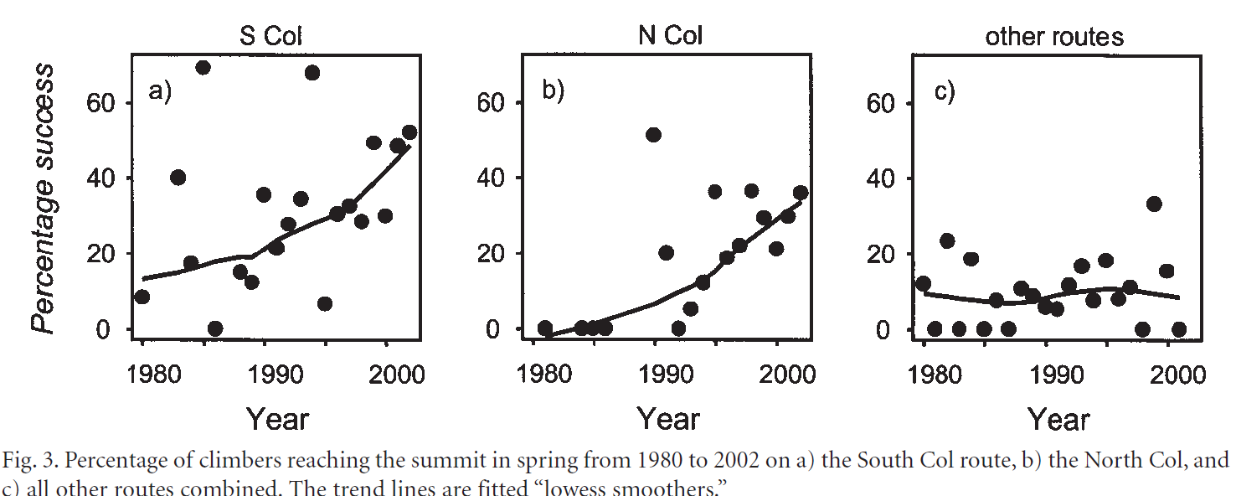

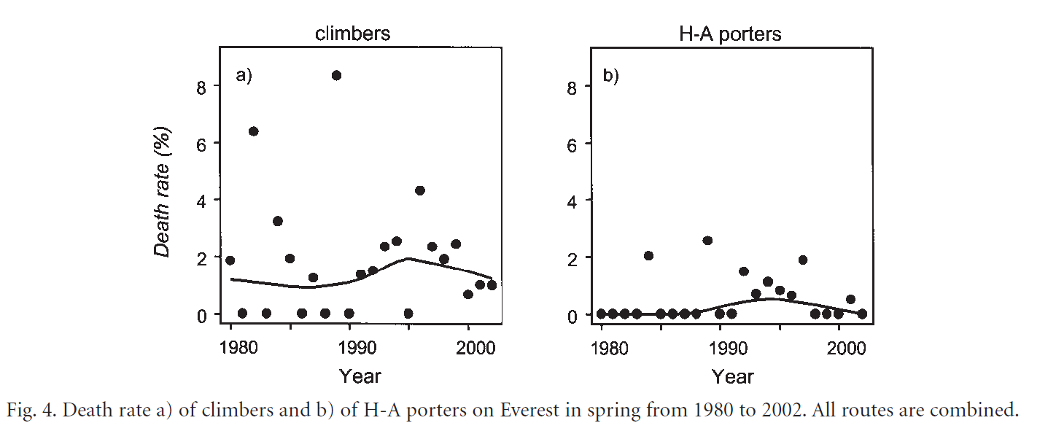

**Quotes: None**

**Paper Credits**

Huey, R. B., & Salisbury, R. (2003a). *SUCCESS AND DEATH ON MOUNT EVEREST*.  
 https://himalayandatabase.com/downloads/Ever-AAJ2003.pdf

### **Paper 13: Limits to human performance: elevated risks on high mountains**

**Dataset** : Himalayan Database

Other datasets: Published records in mountaineering literature such as American Alpine Jornal Himalayan Journal and Hugh.

Temperatures at the South Col (7891 m) of Everest from May 1999 to May

2000. The upper line plots measured air temperatures (data courtesy M. Hawley and

the MIT Media Group).

**Comments:**

1.Study is comparing success rates and death rates on mountains of different heights.

2. Can we predict or classify a death-zone?2.8000m peaks (datapoints = 5085 ascents up to the year 2000)

3. While seeking adventure on those great peaks, mountaineers are inevitably exposed to hypoxia, cold and dehydration as well as to the physical hazards of climbing.

* Hypoxia is **low levels of oxygen in your body tissues**. It causes symptoms like confusion, restlessness, difficulty breathing, rapid heart rate, and bluish skin. Many chronic heart and lung conditions can put you at risk for hypoxia. Hypoxia can be life-threatening.

4. Study contributes to high-altitude medical physiology (Houston, 1998; Hultgren, 1997; Richalet, 1999; Roach et al.,

1999). Remarkably, few studies have **quantified** risk (Town, 1986; Pollard and Clarke, 1988; Huey and Eguskitza, 2000

5. Over 8000m, The primary limiting factor is barometric pressure, which declines exponentially with altitude.

6. Because oxygen makes up 21 % of air at any altitude, the partial pressure and hence availability of oxygen decrease with altitude. As a result, arterial hemoglobin is poorly saturated with oxygen (Peacock and Jones, 1997). The resulting tissue hypoxia not only greatly restricts a climber’s ability to move (Edwards, 1936; Pugh et al., 1964; West et al.,1983; West, 1986b; West, 2000) but also induces serious physiological, medical, sensory and neurobehavioral problems (Hornbein et al., 1989; Houston, 1998; Hultgren, 1997;

Richalet, 1999).

7. At Everest base camp (approximately 5310 m), the barometric pressure is half that at sea level; at the summit itself (8850 m), the barometric pressure is one-third that at sea level (West, 1999; Fig. 1).

8. Other hazards: Low temperatures, high (near jet stream) winds : hypothermia, frostbites,

NOTE: Remarkably, one climber (Ang Rita, 22 December 1987) successfully reached the summit in winter without using supplemental oxygen

**Questions:**

1. How risky is reaching the summit of an 8000m peak?
2. **Does supplemental oxygen enhance survival (Huey andEguskitza, 2000)?**
3. Does the size of a team influence success rate or death rate?
4. How do factors such as height, steepness, difficulty and weather affect success and mortality?
5. Does **risk of death from different cause**s (e.g. avalanche versus illness) change with altitude (Pollard and Clarke, 1988)?

| **Objective** | **Time Range** | **Data filters** | **Missing factor** | **Factors** | **Analysis** | **Results** |
| --- | --- | --- | --- | --- | --- | --- |
| Hypotheses:  (i) Success rate in reaching  the summit is inversely related to a mountain’s height  (ii)Death rates are directly related to mountain height | 1978  -1999 | Climbers who did not use supplemental oxygen  Members only  *Excluded high-altitude porters, sirdars and commercial guides  Death during descent | Weather and snow conditions can change rapidly, as can a  mountaineer’s physical state, adding variability to any real  pattern.  The  standard way to evaluate causation is, of course, to do an  experiment. That is not an option here: imagine how K2  mountaineers would respond to being randomly assigned into  groups ‘using’ versus ‘not using’ supplemental oxygen!  We must assume that climbers on different mountains  are comparable in experience, skill and willingness to accept  risk, but this is certainly not the case (climbers on Rainier are  less skilled and experienced than are climbers on K2).  Climbers also differ in ability to acclimatize to altitude,  concurrent illness and tolerance of physiological adversity. | Altitude or height of the mountain. | -We adopt analytical techniques that were developed for  evolutionary  studies of Natural Selection on organisms  (Endler, 1986; Schluter and Nychka, 1994). For example, we  attempt to determine whether **rates of success or of death**  **correlate with factors such as mountain height, use of**  **supplemental oxygen or team size**.  -A  full analysis of the probabilities of success and  death should consider the influence of as many  such factors as possible; but of necessity here, we  begin with a single-factor (altitude) approach.  -Before we started these analyses of mountaineering  outcomes, we questioned whether meaningful patterns could  in fact be discerned from available data. After all, conclusions  concerning causality might be confounded by several issues.(Weather and snow conditions can change rapidly so can a mountaineer’s physical state). | Our findings are consistent with the  hypothesis that increasing altitude is associated with  decreased success and with increased risk of death.  Consequently, we predict that the probability of successfully  reaching the summit will be inversely related to the altitude of  that peak and that the probability of dying will increase with  altitude, **all else being equal**.  Overall death rate increases with altitude (Table 1; r=0.84,  P=0.04) and is significantly higher for the two 8K peaks  (P=0.04). Similarly, death rate during descent from the summit  increases with a summit’s altitude (Table 1; r=0.83, P=0.04)  and is higher for the two 8K peaks (P=0.04). |
|
|
|
|

**Statistical visualization**

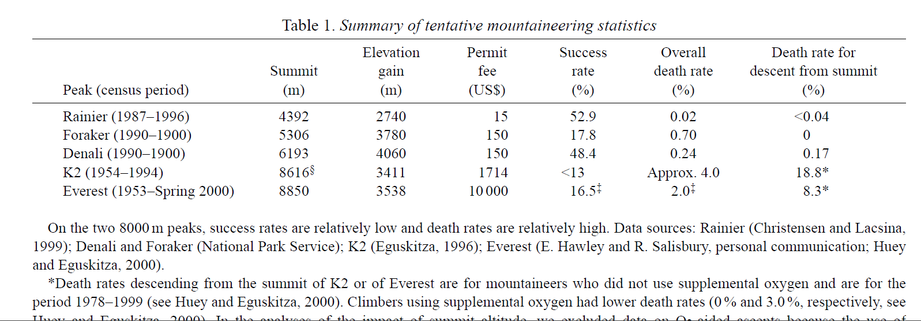

**Quotes:**

‘…for we must remember that even the highest of mountains is capable of severity, a severity so awful and so fatal that the wiser sort of men do well to think and tremble even on the threshold of their high adventure.’

G. H. Leigh-Mallory (1922, p. 279).

**Paper Credits**

Huey, R. B., & Eguskitza, X. (n.d.). *Limits to human performance*.

*Himalayan Database Expedition Archives of Elizabeth Hawley*. (n.d.). Retrieved December 20, 2022, from<https://himalayandatabase.com/Research/JEB2001.html>

### **Paper 14: Supplemental Oxygen and mountaineering deaths**

**Dataset** : Himalayan Database

Other datasets: K2 dataset

Comments:   
1. Supplemental oxygen was first used in the Himalaya just after the tum of the century and extensively by

British Everest expeditions in the 1920s.

2. There is widespread use of supplemental oxygen

3. Does the physiological "benefit" of supplemental oxygen outweigh the "cost" of having to carry heavy and cumbersome backpacks (some weighing more than 30 pounds) and of having to deal with high-resistance masks and unreliable regulators.

4. Benefits: Climbed faster, slept better, speed and performance improves.

5. Some individuals had the physical and men­tal capacity to reach the summit and return safely on ambient air alone

6. "By reaching for an oxygen cylin­der, a climber degrades Everest to the level of a 6000-meter peak "

| **Objective** | **Time Range** | **Data filters** | **Factors** | **Analysis** | **Results** |
| --- | --- | --- | --- | --- | --- |
| Do death rates on K2 and Everest differ depending on whether or not  a climber had used supplemental oxygen.  Subobjectives:  1 Does supplemental oxygen enhance overall performance?  2. Is it required or is ambient air sufficient?  3. ls the use of supplemental oxygen aesthetic or ethical/fair?  4. *Should supplemental oxygen use be required for guides?*  5. *Does supplemental oxygen enhance safety?* | Everest: I978-1999  K2 : 1978=1997  *1978-(first ascent without supplemental oxygen) - | Death rates during descent from the summit of these peaks. | Usage of supplemental oxygen | We decided to investigate whether death rates on K2 and Everest differed depending on whether or not  a climber had used supplemental oxygen  To counteract the effect of a group effect (such as a team that faced a storm and died), team analysis was also carried out.. Thus this analysis counteracts the bias induced in individual death rates by multiple deaths in storms. | Death rates for climbers not usingsupplemental oxygen were significantly higher than for those who did.  On Everest, climbers not using supplemental oxygen had death rates more than double those using supplemental oxygen (8.3 percent vs. 3.0 percent). On K2, the difference is overwhelming (18.8 percent vs. 0 percent).  Correlation established. Causation still in question.  The use of oxygen requires more porters to carry the canisters, thus increasing the size of the team and “exposing” more people to the risk of death. |
|
|
|
|

**Statistical visualization**

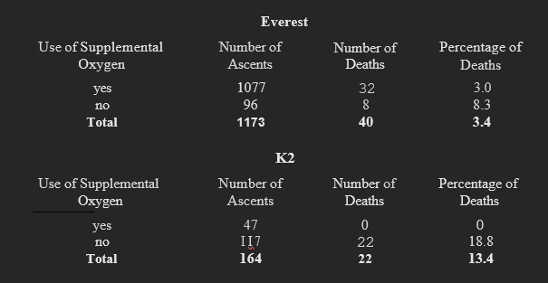

**Quotes:** The higher one climbs, the harder one works to climb.

**Paper Credits**

Eguskitza. (2000). Supplemental oxygen and mountaineering deaths. *Am. Alpine J.*, *2000*, 135–138.